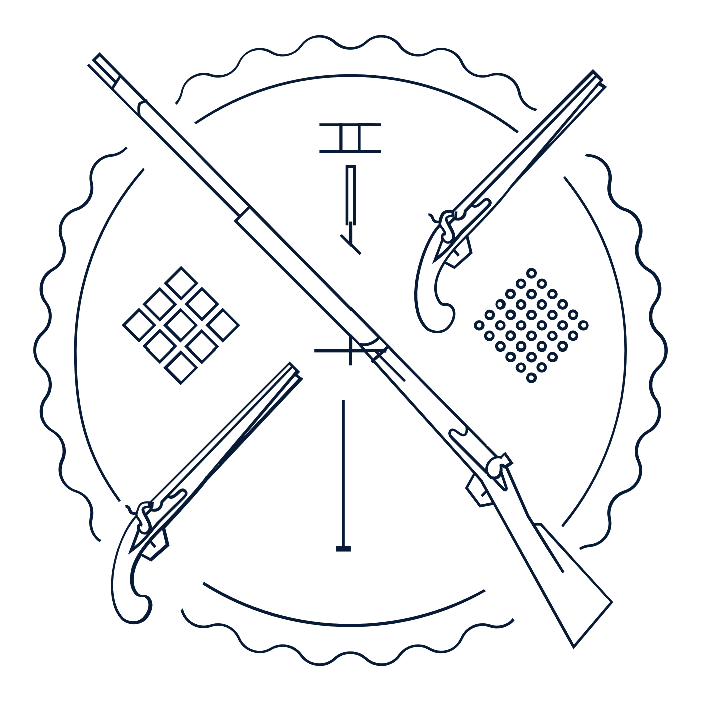
Scholar Exchange: Second Amendment
Introductory Level
Class Outline and Worksheet

INTERACTIVE CONSTITUTION RESOURCES

- Resources for the Second Amendment

OVERVIEW

Part I. Opening Question and Introduction to the Text
Part II. Founding Era
Part III. Civil War and Reconstruction Era
Part IV. Modern Supreme Court Cases and Hypothetical Question

BIG QUESTION

- Why did the Founding generation enshrine the Second Amendment in the Bill of Rights?
- What was the Founding-era vision of the Second Amendment, and how did America’s “Second Founding”—and the ratification of the Fourteenth Amendment after the Civil War—shape the Second Amendment’s meaning?
- How has the Supreme Court interpreted the Second Amendment over time?
- Today, when can the government limit the individual right to possess guns and other firearms—and when can’t it?
- What are areas of constitutional debate over the Second Amendment today?

Part One: Opening Question and Introduction to the Text
What is the big idea of the first part of this Amendment, relating to Militia and State?
What is the big idea of the second part of this Amendment, relating to the “right of the people”?

Part Two: Founding Era Stories
What was one Founding-era concern that the Framers had in mind during the Constitutional Convention?
Why was this a concern for the Framers?

Part Three: Civil War and Reconstruction Era Founding
What were some ways that the Civil War and Reconstruction transformed debates over the Second Amendment?

Part Four: Modern Supreme Court Cases
Complete the chart with information about one of the modern Second Amendment cases. District of Columbia v. Heller (2008) and McDonald v. City of Chicago (2010)

Court Case | What was the question? | How did the Court rule?

Notes and Questions:

