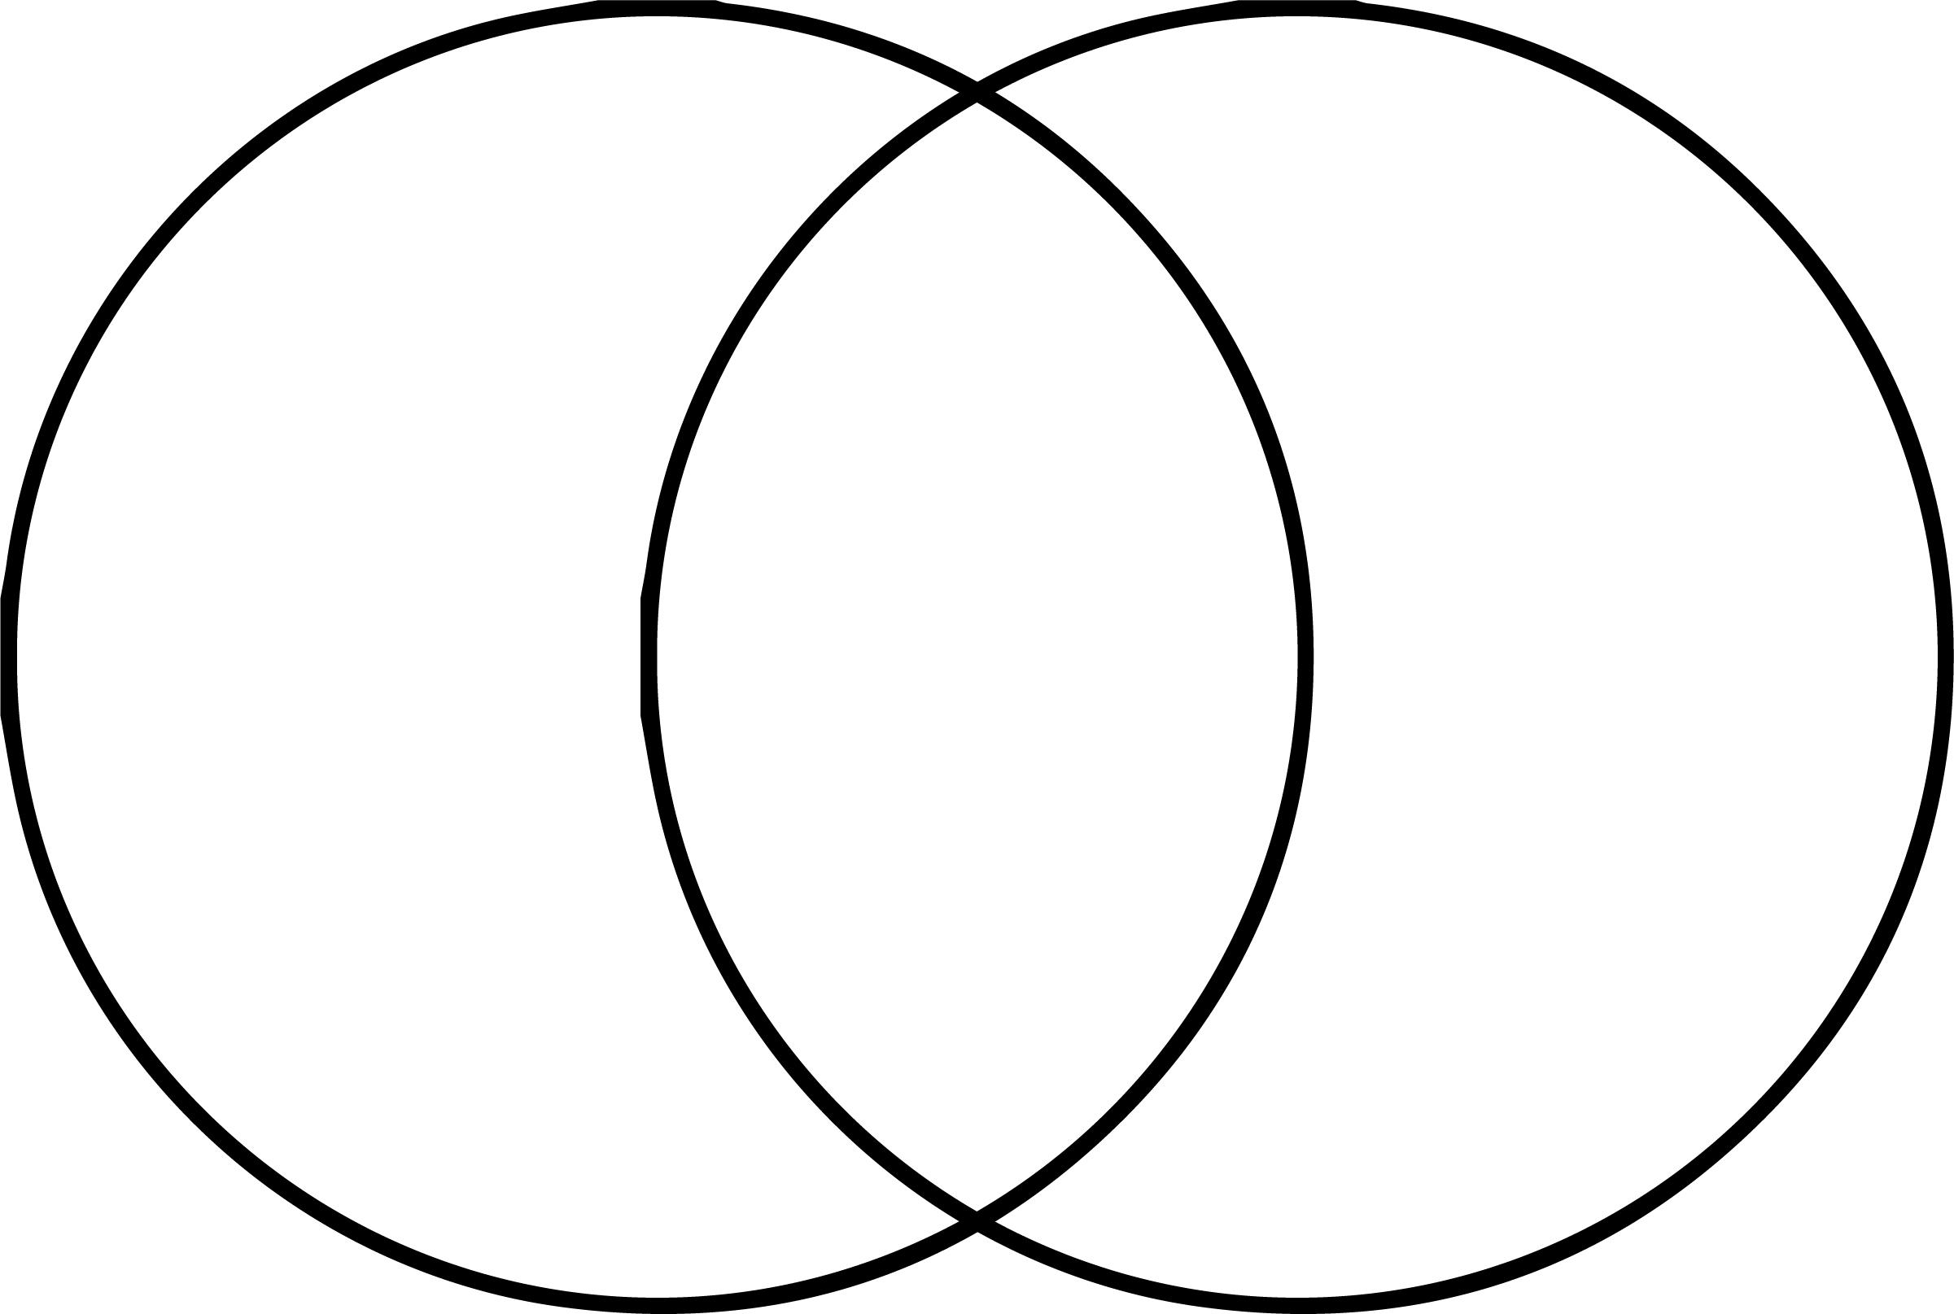

Mason's
Speech
Similarities
Wilson’s Speech

