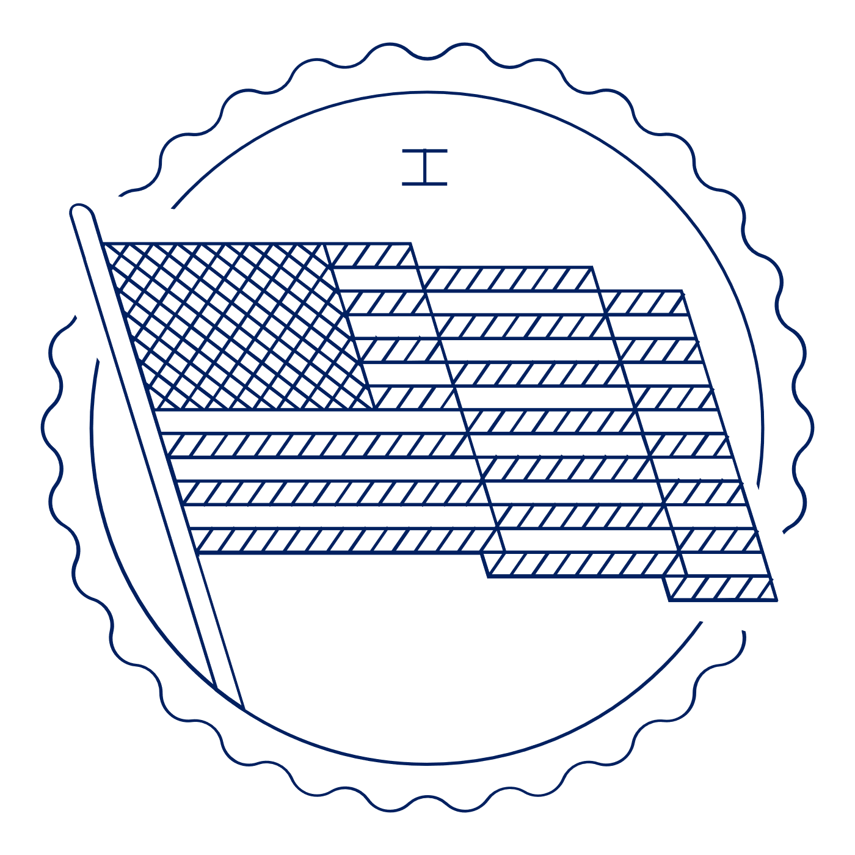
Scholar Exchange: First Amendment – Speech and Press
Advanced Level Class Outline and
Worksheet

OVERVIEW

Part I. Introduction to the Free Speech and Press Clauses
Part II. Speaking Out Against the English Government
Part III. Founding Stories
- Alien and Sedition Acts (1798): First Major Test of Free Speech
- Free Speech and Abolitionist
- World War I (1910s) and the Supreme Court
- New York Times v. Sullivan and the Civil Rights Movement
Part IV: Free Speech Today
Part V. Free Speech in Public Schools

INTERACTIVE CONSTITUTION RESOURCES

- Resources for the First Amendment Speech and Press

INTRODUCTION

Big Questions

- What was the Founding generation’s vision for the First Amendment’s protection of free speech and a free press?
- What are some of the key periods in history that have tested the nation’s commitment to free speech?
- How has the Supreme Court interpreted the First Amendment’s commitment to free speech and a free press over time?
- How does the Supreme Court analyze free speech and free press cases today?

Big Idea
Today, the Supreme Court protects free speech rights more strongly than at any time in our nation’s history—and American free speech protections are among the strongest in the world. Generally speaking, the government may not jail, fine, or punish people or organizations based on what they say or write, and the Court protects speech unless it is likely to cause immediate lawless action. (A standard rarely met in practice). At the same time, there are certain contexts when the government has more leeway to regulate speech—for instance, with low-value speech like defamation or when speakers (like public school students) have a special relationship with the government.
FIRST AMENDMENT TEXT
“Congress shall make no law . . . abridging the freedom of speech, or of the press…”
What is covered? | What is not covered?

When originally written, the First Amendment only applied to what level of government?
What amendment changed that?

FOUNDING STORIES
Pick two times in U.S. History when laws or acts were created to either restrict or expand Freedom of Speech.
 | Story One: | Story Two:
Who created the laws/acts?
What was happening in the United States when these were created?
What did the laws do?
What was the response?

MODERN FIRST AMENDMENT INTERPRETATIONS
Provide details about one Freedom of Speech Supreme Court case discussed between 1910 and 1970.
Who was involved?
What was the issue of the case?
How did the Supreme Court rule?
What does the decision show about the changing views of Freedom of Speech during this time period?

Limited Speech Under the First Amendment
What is one situation when the government can restrict speech?
What is an example of this restriction?

FREE SPEECH IN SCHOOLS
Tinker v. Des Moines Independent Community School District (1969)
What is the background of this case?
What did the Court decide?
What is one other case involving speech in schools that the Court decided since Tinker?
How does that case add to the understanding of speech in schools from Tinker?

