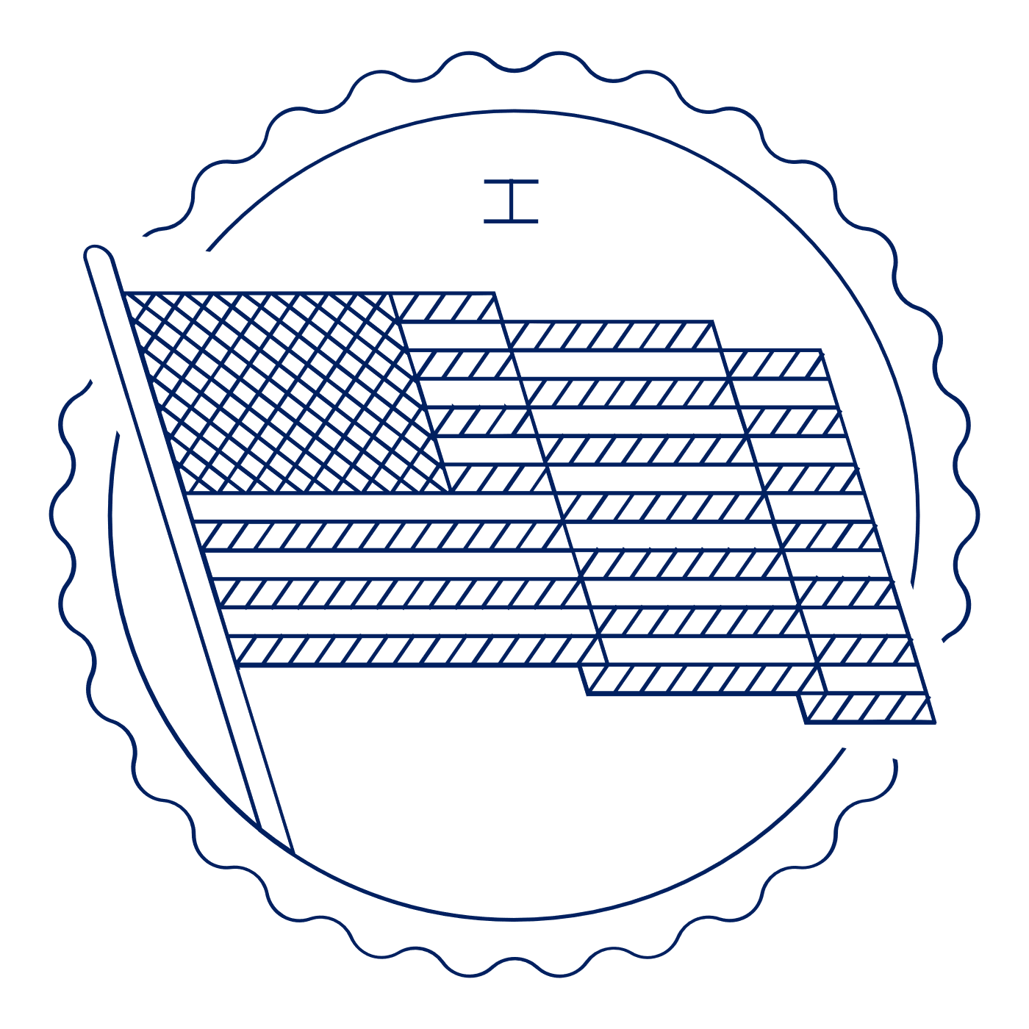
Scholar Exchange: First Amendment — Assembly and Petition
Briefing Document

INTERACTIVE CONSTITUTION

- Resources for the First Amendment and Freedom of Assembly and Petition

INTRODUCTION

Big Questions

- Why did the Founding generation include assembly and petition rights in the First Amendment?
- How did the Founding generation exercise their assembly and petition rights?
- How have constitutional movements throughout history used assembly and petition rights to push for constitutional change?
- How has the Supreme Court addressed assembly rights over time?
- What are some of the key constitutional debates over assembly and petition rights?
- How can you assert your rights to freedom of assembly and petition today?

Big Idea

Throughout American history, minorities and those without power have used assembly and petition rights to find voice and power in their quest for greater freedom and equality. The list includes African Americans, women, unpopular political groups (e.g., abolitionists in the early 1800s), and many others.

FIRST AMENDMENT TEXT: AN INTRODUCTION TO THE CLAUSES

Let’s begin—as we always do when interpreting the Constitution—with the Constitution’s text:

“Congress shall make no law . . . abridging . . . the right of the people peaceably to assembly, and to petition the government for a redress of grievances.”

The Clause’s reference to a singular “right” has led some courts and scholars to assume that it protects only the right to assemble in order to petition the government. And it’s easy to understand why. But looking again at the Amendment’s text, the comma after the word “assemble” is left over from earlier drafts of the First Amendment that made it clearer that the Founders wanted to protect both assembly and petition.

Ultimately, this language is best read as protecting two distinct rights.

First, the freedom of assembly protects our right to gather together with others in groups—whether as part of a political meeting, religious gathering, street protest, or parade.

And second, the right to petition goes to our right to join together with others to share our collective views with the government—often by highlighting problems and suggesting ways of fixing them.

The freedoms of assembly and petition haven’t been the subject of many great Supreme Court decisions in recent years. Even so, the rights of assembly and petition themselves were important to the Founding generation and have played a significant role in America’s constitutional story from the beginning.

THE FOUNDING STORY OF THE ASSEMBLY CLAUSE

The Impact of William Penn

For James Madison and the Founding generation, the right of assembly was closely connected to a famous (for them, at least) episode in history—the arrest and trial of William Penn for participating in religious worship with others in 1670. (Widely known as “Bushell’s Case.”)

In fact, debates in the House of Representatives during the battle over the Bill of Rights—including the First Amendment—specifically linked the Amendment’s protection of “assembly” to the famous example of William Penn’s arrest and trial, which dealt with assembly, not petition.

First a bit about William Penn. Penn was a Quaker. He was the founder of Pennsylvania. Following his arrest and trial, he would receive a charter from King James II to start Pennsylvania and depart England in 1681. Penn’s trial took place in England a little over a decade earlier.

England had an official religion—the Church of England, headed by the King. And England’s Conventicle Act banned religious assembly of over 5 people outside of the official church.

Penn was arrested for holding a Quaker meeting in violation of this law. Simply put, he was preaching his Quaker faith in public. Defying the royal judge, Penn’s jury initially refused to punish him for unlawful assembly even though he was clearly guilty under the letter of the law. The judge then imprisoned members of the jury overnight without food, water, or heat—threatening to keep them there until they convicted Penn.

Penn shouted to the jury, “You are Englishmen, mind your Privilege, give not away your Right.”

The jury still said that Penn wasn’t guilty. The judge then fined the jury for contempt of court—in other words, for defying him and ruling in Penn’s favor—and sent them to prison until they paid the fine.

One of the jurors challenged this move—securing a win in the Court of Common Pleas, which concluded that a judge may not imprison a jury for refusing to rule the way the judge would like.

Background on the Right of Assembly

The freedom of assembly protects our right to gather together with others in groups—whether as part of a political meeting, religious gathering, street protest, or parade.

There are few Supreme Court decisions squarely on the right of assembly, but many sets of cases touch on it. And there is often an overlap between assembly rights and free speech rights—as both the historical examples and the Supreme Court’s decisions show.

The assembly right is the only right in the First Amendment that requires more than a lone individual. You can speak alone. But you can’t assemble alone. And while some assemblies occur spontaneously, most don’t. For this reason, the assembly right extends to the prep work before the physical act of gathering.

In part to protect this work, the Supreme Court eventually recognized a “right of association.” This right doesn’t appear in the text of the First Amendment, but it can serve a key role in realizing the assembly right. Before gathering in public, you often need to form a group of some kind. This often requires building relationships, developing ideas, and forming social bonds. The right of association protects groups from unwarranted government interference with these activities.

In particular, the Supreme Court has recognized a category of groups engaged in “expressive association.” (Roberts v. United States Jaycees (1984)). The basic idea is that groups are eligible for constitutional protection to the extent that their purposes and activities further some other First Amendment interests like speech, press, or religion.

Here’s how the Supreme Court put it: “Implicit in the right to engage in activities protected by the First Amendment” is “a corresponding right to associate with others in pursuit of a wide variety of political, social, economic, educational, religious, and cultural ends.” It’s important to note that some groups don’t fall into this category. And the Court has sometimes limited the right of association—just as it has various other rights.
Returning to the assembly right as a whole, assembly is often a form of mass communications—through the gathering of many people. Often the gathering itself—and its size and composition—is a key part of the message.

For example, a demonstration, picket-line, or parade often conveys more than the words on a sign or the chants of the crowd. An assembly is—more or less, in a certain sense—“free,” since it allows individuals to engage in mass communications powered by “sweat equity,” the efforts of many people fighting to be heard.

Big Idea:

Protects dissenters and unpopular groups, all groups. E.g., religious minorities, unpopular groups, labor activists, civil rights groups, etc. This can even include the right to protest and picket a military funeral.

HISTORICAL EXAMPLES OF ASSEMBLY CLAUSE CASES

The assembly right has been especially important to groups challenging the status quo.

Democratic-Republican Societies.

These were political organizations—connected with Thomas Jefferson and James Madison—designed to build political opposition to the Federalist government.

Abolitionists.

While we think of abolitionists—those leading the fight against slavery—as heroes today, they were extremely unpopular in their own time. And not just in the South. National leaders from the North explicitly denounced them as dangerous and disloyal instigators of the Civil War. They were seen as rabble-rousers—sowing discord and threatening violence among white Americans.

Now, why did so many people denounce the abolitionists—or worse? What were they afraid of? They were afraid of the effects of the abolitionist message. Many feared slave revolts throughout the South. And this led many to believe that the abolitionist expression was different. That it must be restricted or banned.

That’s why before the Civil War, we had laws in states like North Carolina and Alabama banning expression with a tendency to incite violence or insurrection. That’s why Missouri banned anti-slavery speeches or expression. And that’s why states across the South strictly limited abolitionist meetings. And when abolitionist groups tried to mail their materials throughout the country in the 1830s, Southern states (especially South Carolina) responded by destroying the mail and preventing it from being delivered. And—with the support of Andrew Jackson—Congress passed the Post Office Act, asking postmasters to support local censorship laws. Even in Philadelphia, an 1835 mass meeting resolved that actions of the abolitionists, “in organizing societies, maintaining agents, and disseminating publications intended to operate upon the institutions of the South” are “unwise, dangerous, and deserving emphatic reprehension and zealous opposition.”

And political and community leaders often organized mobs to suppress abolitionist meetings and expression—sometimes leading to violence and even death.

Again, and perhaps most famously, the death of Illinois printer Elijah Lovejoy in 1837. We had mob violence throughout the West and South and riots in NYC and Philadelphia.

African American Conventions.

These were groups of African Americans meeting before, during, and after the Civil War to offer a vision of freedom and equality for all Americans and demand these rights for African Americans.

For example, take Frederick Douglass’s “A Plea for Free Speech” in Boston 1860. There, Douglass was responding to a history of mob leaders—usually community leaders or political leaders—explicitly designing mobs to suppress abolitionist meetings and expression. In his “Plea,” Douglass calls for respecting the right to speech and assembly against mob violence.

Women’s Suffragists

Women drew on assembly rights to fight for women’s right to vote. While they couldn’t vote, women organized a series of conventions promoting a vision of sex equality—at home, at work, and at the ballot box.

The most famous example is the Seneca Falls Convention in 1848. There, the Convention produced one of the most famous documents in American history—the Declaration of Sentiments. It used the Declaration of Independence as its model—explaining a series of wrongs against women and advancing a vision of an America in which men and women were treated equally.

Or fast forward to the twentieth century. The first ever protest at the White House was held by women—including Alice Paul among other suffragists—fighting for their right to vote.

After Woodrow Wilson’s reelection, in 1916, Paul called for members of the National Women’s Party to picket the White House to put pressure on Democratic Senators to vote for the Nineteenth Amendment—protecting women’s right to vote. They held up banners that drew on the language of the Declaration of Independence and the American Revolution. For instance, one read: “Governments derive their just powers from the consent of the governed.”

Initially, the picketers were mostly left alone, and President Wilson would even wave to them. But after the U.S. entry into World War I, things changed. And police began arresting women outside the White House. But women kept protesting.

And President Wilson eventually relented, giving his support to the Nineteenth Amendment in January 1918.

Extending the Right of Assembly to the States

The Supreme Court extended the right of assembly beyond the national government and applied it to state abuses—what lawyers call incorporation—in the unanimous 1937 decision—De Jonge v. Oregon.

The case involved a peaceful meeting of Communists in Oregon. The communists were arrested and tried under Oregon law for meeting as part of a group that sought, in part, to violently overthrow the government.

Even so, the Supreme Court threw out the conviction and recognized that “the right of peaceable assembly is a right cognate to those of free speech and free press and is equally fundamental.”

Use of the Right to Assembly Today

Some examples are parades, protests, and the like. But there are also time, place, and manner regulations on these events.

Most public gatherings—like protests—are governed by (what the Supreme Court refers to as) public forum doctrine. The idea is pretty simple in theory. The government is allowed to regulate expressive activity in public spaces—like protests and parades—through (what the Court calls) reasonable “time, place, and manner” restrictions.

Time, place, and manner regulations include things like rules that require you to get a permit before holding a parade. Or that tells you that you can’t make loud noises at night, when people might be sleeping—or next to a school, where students may be learning.

The idea is that the government can’t restrict the message, but it can sometimes regulate when you say it—or how loudly you say it—in order to maintain the public’s health, safety, and welfare.

So, practically speaking, while the Supreme Court recognizes an abstract First Amendment right to gather together on streets and in parks for meetings, speeches, parades, protest marches, picketing, and demonstrations, it also grants the government—usually police officers—broad discretion to regulate public assemblies in the name of preserving public order.

And the Court has upheld regulations on political protests, parades, and labor picketers—to name just a few groups. Technically, these cases rarely mention the right of assembly. But this is simply a quirk of how the Supreme Court formally speaks about these cases. They clearly go to the core of our right of assembly.

THE FOUNDING STORY AND FREEDOM OF PETITION

Freedom of Petition

The right to “petition the Government for redress of grievances” is among the oldest in our legal heritage, dating back 800 years to the Magna Carta, and receiving explicit protection in the English Bill of Rights of 1689, long before the American Revolution.

Ironically, the modern Supreme Court has all but read the venerable right to petition out of the Bill of Rights, effectively concluding that it’s been rendered obsolete by an expanding Free Speech Clause. But, as with assembly, the right to petition wasn’t simply an afterthought to the Founding generation—or to the many generations that followed.

Big Idea:

The petition right goes to our right to share our collective views with the government—often by highlighting problems and suggesting ways of fixing them. And while the right to petition hasn’t played a large role at the Supreme Court, it has an important place in American constitutional history. The colonists used petitions to reach out to the British Crown in the colonial period, raising their complaints—with famous examples like John Dickinson’s “Olive Branch” petition. We used it to justify our split from England, with the Declaration of Independence following years of ignored petitions by the colonists to King George III.

Mechanics of the Petition Right in Early American History

In the early years of America, legislatures felt bound to consider and respond to petitions. And the petition right also served the purpose of informing elected representatives about local conditions and popular sentiments.

So, in the Founding era, you could walk into Congress with something that looked like a complaint but was a petition to your member of Congress. The petition was read on the floor of Congress—with formal recording and hearing.

The petition right has traditionally been open to everyone equally, including women, African Americans, Native Americans, non-citizens, and even children. This open petition right was foreign concept elsewhere in the world.

So, like the assembly right, it was a key way for disadvantaged groups to be heard. Even when groups couldn’t vote or hold office, they could petition their government and express their views.

HISTORICAL EXAMPLES OF PETITION CLAUSE CASES

Prince Hall and His Abolition Petition

For instance, in January 1777, Prince Hall offered a petition for freedom to the Massachusetts House on behalf of seven African Americans. Hall, in fact, began his petitioning campaign to end slavery in 1773, but after 1776, his petition could draw on the Declaration of Independence, arguing that slavery violated natural law. And this was just one of many similar petitions brought in Massachusetts—using the American Revolution and the language of liberty through the right of petition to destroy slavery. Notably, this movement was ultimately successful—by 1783, the Massachusetts Supreme Court agreed with Hall that slavery violated natural law and the principles of the Declaration, ending slavery in the state.

Benjamin Franklin and the Abolition Society

One of the most famous examples is when Benjamin Franklin presented an anti-slavery petition to Congress in 1790.

Pennsylvania had the first abolition society in the country—founded in April 1775. The Quakers took a lead role in the society. A decade later, Benjamin Franklin was elected the Society’s president.

Franklin turned to the abolitionist cause late in life—the last enslaved person in his house died in 1781. But he had become friends with a number of antislavery activists in his time in Britain and France and he had long been exposed to the abolitionist views of Quakers. And he became an outspoken critic of slavery after the ratification of the U.S. Constitution, publishing several essays calling for slavery’s abolition. In his final public act, he sent a petition—signed in February 1790—to Congress on behalf of the Pennsylvania Abolition Society, calling for the abolition of slavery and an end to the slave trade.

It called for the First Congress to “devise a means for removing the Inconsistency from the Character of the American People” and “to promote mercy and justice towards this distressed Race”—namely, African Americans.

The petition also read: “That mankind are all formed by the same Almighty being, alike objects of his care & equally designed for the Enjoyment of Happiness the Christian Religion teaches us to believe & the Political Creed of America fully coincides with the Position.” Here, “political creed” was a clear reference to the principles of the Declaration of Independence.

The petition was introduced in the House and Senate shortly thereafter. Pro-slavery forces denounced the petition—and it sparked a heated debate in both the House and the Senate. South Carolina Senator Ralph Izard, for instance, took issue with the “fanatics” of the Pennsylvania Society, while his fellow South Carolina Senator Pierce Butler accused Franklin of pushing the country towards disunion because, “The doctor, when a member of the Convention has consented to the federal compact. Here he was acting in direct violation of it.”

The Senate took no further action on the petition while the House sent it to a select committee. The House eventually tabled the resolution—putting it to the side—and argued that the Constitution limited Congress’s power to end the slave trade until 1808. This ended the debate on slavery in the First Congress.

Franklin died two months later.

James Madison’s Memorial and Remonstrance

In 1785, James Madison’s Memorial and Remonstrance—was circulated as one of several petitions that gained more than ten thousand signatures. And this was taken as a concrete signal of public support and proved decisive in the Virginia legislature’s eventual decision to adopt its famous Bill for Establishing Religious Freedom—an important precursor to the First Amendment’s religion clauses, which we discussed last week.

Anti-Slavery Petitions in 1830s, John Quincy Adams, and Congressional “Gag Rule”

Another famous example involves anti-slavery petitions in 1830s, John Quincy Adams, and the battle over Congress’s “gag rule.”

A gag rule limits or bans discussing a particular topic in a legislative body.

John Quincy Adams, after being defeated for a second term as President, was elected to the House of Representatives.

Between 1831 and 1836, anti-slavery forces led a massive petition drive—resulting in over 100,000 petitions sent to the House of Representatives and the Senate, mostly asking for Congress to either abolish slavery or restrict the expansion of slavery.

John Quincy Adams—elected to the House after his Presidency—usually took the lead in introducing these petitions, provoking a near riot. The House leadership—driven by pro-slavery forces—responded by imposing a “gag rule” limiting petitions. This rule automatically tabled anti-slavery petitions, prohibiting them from being read or discussed. The argument was that Congress shouldn’t act on them because the national government didn’t have the constitutional power to attack slavery in the states.

Adams argued that the gag rule violated the First Amendment’s right “to petition the Government for a redress of grievances.” The petitions kept coming anyway—with 1,500 more between December 1838 and March 1839 alone—mostly about abolishing slavery in Washington D.C., ending the slave trade, and ending slavery’s expansion.

Congress eventually got rid of the gag rule, with the House concluding that it was unconstitutional in 1844, ending it by a 108-80 vote.

Adams wrote the repeal resolution and secured the votes to pass it.

Thirteenth Amendment Petition Drive (Led by Susan B. Anthony and Elizabeth Cady Stanton)

In January 1864, Susan B. Anthony and Elizabeth Cady Stanton—through the Women’s Loyal National League—kicked off a petition drive in support of the abolition of slavery.

This petition drive was a huge success, and the League presented Congress with a huge emancipation petition bearing one hundred thousand signatures, nearly two-thirds of them, women. On February 9, Senator Charles Sumner—the great abolitionist Senator from Massachusetts—introduced the first 100,000 signatures from the petition drive to the Senate.

Here’s how Sumner biographer David Herbert Donald describes the scene: “The documents were so bulky that no one man could carry them. Dramatically, two tall men bore the massive roll into the Senate chamber and deposited them on Sumner’s desk.”

Sumner then presented the petition to the Senate.

Later, Sumner argued that this petition drive was a key force in the eventual passage and ratification of the Thirteenth Amendment.

African American Convention’s Equal Citizenship Petitions

Throughout the United States—before, during, and after the Civil War—African Americans met in conventions to advance a vision of racial equality and used petitions to share their views with the government.

For instance, in 1865, Charles Sumner offered a petition to the Joint Committee on Reconstruction from newly freed slaves in South Carolina calling for “constitutional protection in keeping arms, in holding public assemblies, and in complete liberty of speech and of the press.”

Petitions for Women’s Suffrage

Finally, in 1866, Susan B. Anthony and Elizabeth Cady Stanton spearheaded a petition drive that led thousands of women to petition Congress for the right to vote.

PETITION CASES OVER TIME AND INTO THE MODERN ERA

At the Founding, and for much of American history, the right of petition protected a formal, transparent platform for individuals — and, in particular, minority — voices to participate in the lawmaking process. Without regard to the number of signers or the political power of the petitioner, petitions received equal process and consideration. This platform allowed both the enfranchised and disenfranchised to gain access to lawmakers on equal footing. Women, African Americans, and Native Americans all engaged in petitioning activity, and Congress attended to each equally.

Legislatures in the Revolutionary period and long into the nineteenth century deemed themselves duty-bound to consider and respond to petitions, which could be filed not only by eligible voters but also by women, enslaved people, and non-citizens. Some scholars have even argued that the Petition Clause includes an implied duty to acknowledge, debate, or even vote on issues raised by a petition.

*Research provided by Nicholas Mosvick, senior fellow for constitutional content, and Thomas Donnelly, senior fellow for constitutional studies, at the National Constitution Center.

