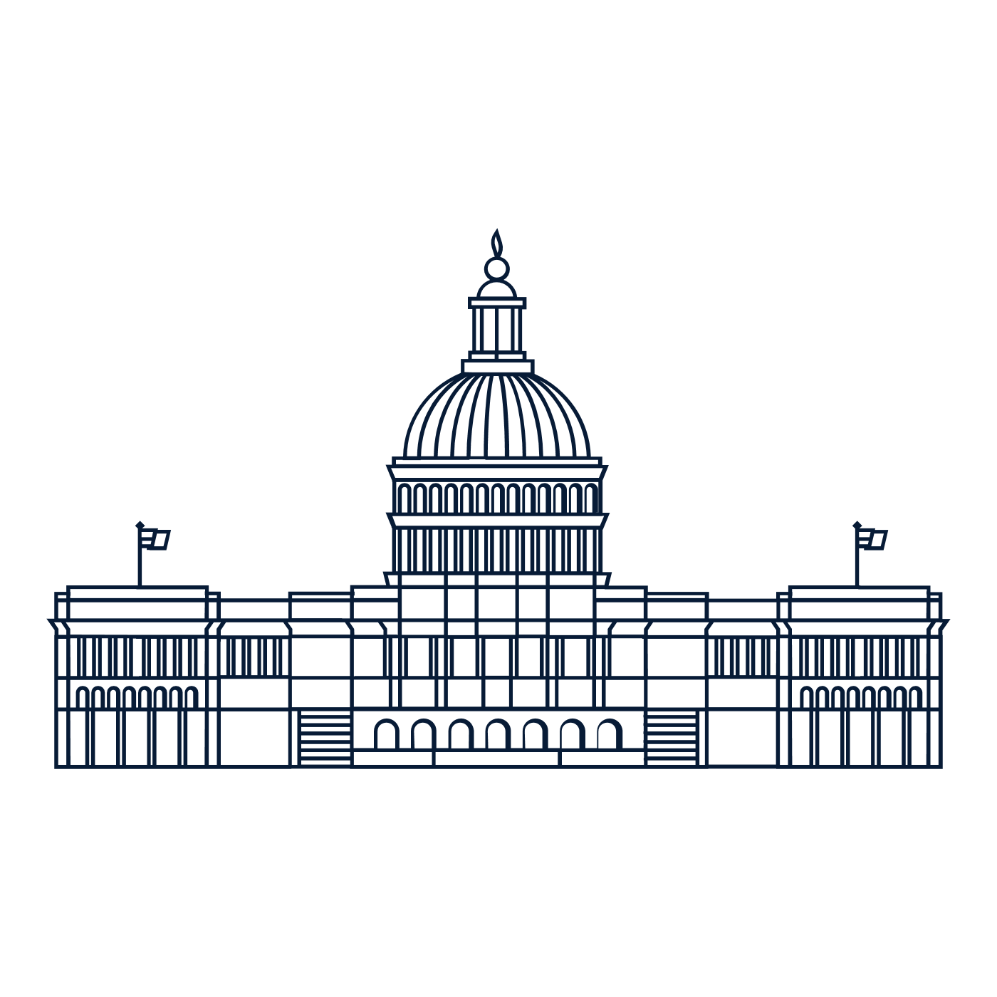

Scholar Exchange: Article I - How Congress Works
Advanced Level
Class Outline and Worksheet

INTERACTIVE CONSTITUTION RESOURCES

- Resources for Article I

OVERVIEW

I. Introduction of the Constitution’s Text
II. How does Congress Work?
III.Founding Story: The Constitutional Convention
IV. Congress’s Power Throughout History
V. Hypothetical: National Mask Mandate

QUESTIONS TO CONSIDER

- What role does Congress have in the national government?
- What powers does the Constitution grant to Congress? And what are some of the limits on congressional power?
- How did the Framers come up with Congress, and what were some of the debates at the Constitutional Convention?
- Has the original vision for what Congress should be changed over time?
- What are some of the Supreme Court’s key decisions on congressional power? And what are some of the topics of ongoing constitutional debate?
BIG IDEA

The power to make laws in our country falls into the hands of the Legislative Branch. The branch is outlined in Article I of the Constitution. The Legislative Branch is divided into two houses of Congress. The House of Representatives is made up of representatives proportionate to their state’s population, while each state maintains equal representation in the Senate. With Congress, the Founding generation set up a national legislature to make the nation’s laws. They intended to create a new national legislature with more authority—and ability to act—than the one that came before it, but also one of limited powers and slow deliberation required to make change. Through five different periods in United States history, the powers and roles of Congress have shifted to create the Legislative Branch as we know it today.
I. INTRODUCTION TO THE CONSTITUTION’S TEXT
What were some considerations the Framers made when they created the legislative branch?

II. HOW DOES CONGRESS WORK?
Why did the Framers create a difficult process for a bill to become a law?

III. THE FOUNDING STORY: THE CONSTITUTIONAL CONVENTION
Summarize one of the debates about Congress that occurred during the Convention.

What was the debate about?
What happened that led to the debate’s resolution?
How was the debate resolved?

What are two powers the Constitution grants Congress?

IV. CONGRESS’S POWER THROUGHOUT HISTORY
Describe at least TWO eras in American history in which the powers of Congress were expanded or limited.

Era: | How did the role of Congress change?
Era: | How did the role of Congress change?

V. HYPOTHETICAL: NATIONAL MASK MANDATE

Does Congress have the power to pass a law requiring everyone to wear a mask during the COVID-19 pandemic?

What is a constitutional hook Congress could use to pass a national mask mandate?
What are some points that support your claim?
What are some points that refute your claim?

