QUOTES ON VISIONS OF PRESIDENTIAL POWER

Review the presidential quotes and try to guess which historical figure said which quote. Hints are also provided.

Alexander Hamilton  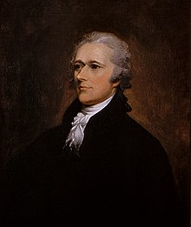 | William Howard Taft  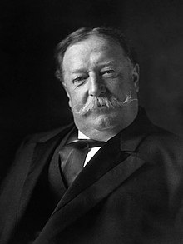 | Theodore Roosevelt  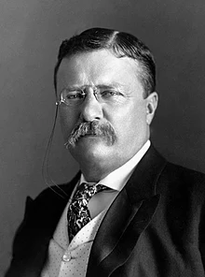 | Woodrow Wilson  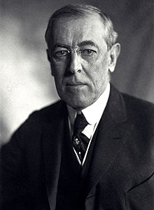

Historical Figure | Quote
“My view was that every executive officer, and above all every executive officer in high position, was a steward of the people bound actively and affirmatively to do all he could for the people, and not to content himself with the negative merit of keeping his talents undamaged in a napkin. I declined to adopt the view that what was imperatively necessary for the Nation could not be done by the President unless he could find some specific authorization to do it. My belief was that it was not only his right but his duty to do anything that the needs of the Nation demanded unless such action was forbidden by the Constitution or by the laws.”

Hint: This figure issued 1,081 Executive Orders, which was significantly higher than any of his predecessors.
“[T]he President can exercise no power which cannot be fairly and reasonably traced to some specific grant of power or justly implied and included within such express grant as proper and necessary to its exercise.”

Hint: Following his presidency, this figure served as chief justice of the United States.
“The makers of the Constitution seem to have thought of the President as what the stricter Whig theorists wished the king to be: only the legal executive, the presiding and guiding authority in the application of the law and the execution of policy. His veto upon legislation was only his ‘check’ on Congress, – was a power of restraint, not of guidance. He was empowered to prevent bad laws, but he was not to be given an opportunity to make good ones. As a matter of fact he has become very much more. He has become the leader of his party and the guide of the nation in political purpose…”

“Some of our Presidents have deliberately held themselves off from using the full power they might legitimately have used, because of conscientious scruples, because they were more theorists than statesmen. They have held the strict literary theory of the Constitution, the Whig theory, the Newtonian theory…. But the makers of the Constitution … were statesman, not pedants….. The President is at liberty, both in law and conscience, to be as big a man as he can. His capacity will set the limit; and if Congress be overborne by him, it will be no fault of the makers of the Constitution, it will be from no lack of constitutional powers on its part, but only because the President has the nation behind him, and Congress has not. . . .”

Hint: This figure was commander-in-chief during World War I.
“THERE is an idea, which is not without its advocates, that a vigorous Executive is inconsistent with the genius of republican government. The enlightened well-wishers to this species of government must at least hope that the supposition is destitute of foundation; since they can never admit its truth, without at the same time admitting the condemnation of their own principles. Energy in the Executive is a leading character in the definition of good government. It is essential to the protection of the community against foreign attacks; it is not less essential to the steady administration of the laws; to the protection of property against those irregular and high-handed combinations which sometimes interrupt the ordinary course of justice; to the security of liberty against the enterprises and assaults of ambition, of faction, and of anarchy...”

Hint: This figure outlined the role of the presidency in The Federalist Papers.

Answers - 1:TR, 2:WHT, 3:WW, 4:AH

