GET TO KNOW AN ENLIGHTENMENT THINKER: ARISTOTLE

Review the information sheets about four key Enlightenment thinkers, and complete the chart based on information about your assigned individual.
___________

Name | Aristotle
Photo | 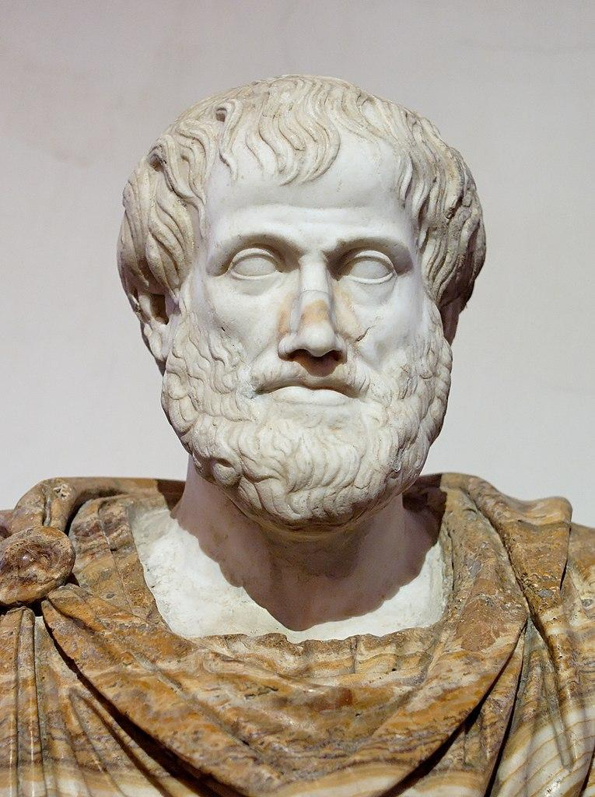
I lived from years ____ to ____.
Three facts about me are…
My closest associates were…
My key writings include…
My ideas shaped the
American Revolution by…

