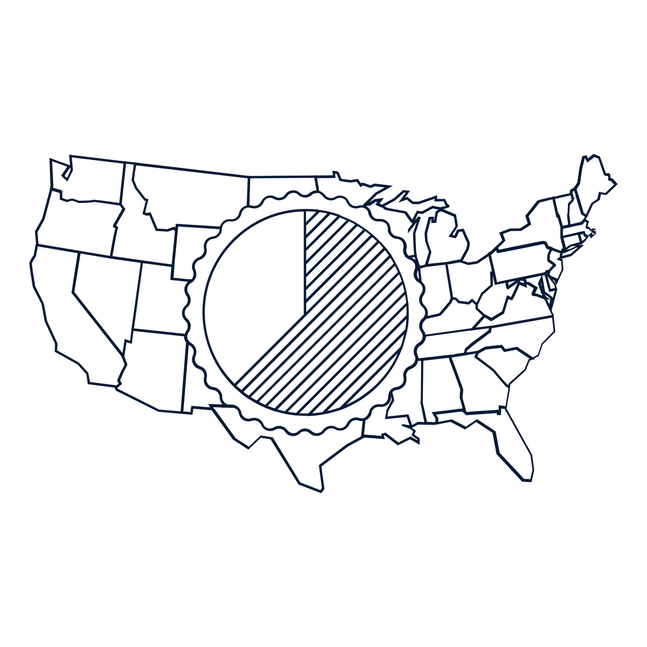

**Scholar Exchange: Article V – The Amendment Process**

**Class Outline and Worksheet**

**Overview**

**Part I: Text of the Constitution and Big Ideas**

**Part II: Founding Story: The Constitutional Convention and the Amendment Process**

**Part III: Examples of Constitutional Amendments Over Time**

**Questions to Consider**

* Why did the Founding generation include a formal process for amending the [Constitution](https://constitutioncenter.org/interactive-constitution/the-constitution)?
* How does the Constitution’s amendment process work, and why did the Founders make it so hard to amend the Constitution?
* What’s the relationship between the Constitution’s [Article V](https://constitutioncenter.org/interactive-constitution/article/article-v) amendment process and [key foundational principles](https://constitutioncenter.org/interactive-constitution/learning-material/foundations-of-democracy) like popular sovereignty and the rule of law?
* What key changes have the American people made to the Constitution over time?

**Big Idea**

[Article V](https://constitutioncenter.org/interactive-constitution/article/article-v) of the Constitution says how the [Constitution](https://constitutioncenter.org/interactive-constitution/the-constitution) can be amended—that is, how provisions can be added to the text of the Constitution. The Constitution is not easy to amend; only 27 amendments have been added to the Constitution since it was adopted.

**NOTES:**

**I. the amendment process and foundations of american democracy**

|  |
| --- |
| Which foundation of American democracy is the amendment process rooted in? How did Abraham Lincoln describe this connection? |
| **Foundation of Democracy in Article V:** |
| **Why?** |

**II. MAjor Amendments and critical amendment periods**

|  |  |  |
| --- | --- | --- |
| Describe the major sets of amendments using the categories below. Name and briefly describe three amendments in each set. | | |
| **First Big Group’s Title:** | **Second Big Group’s Title:** | **Other Amendments**  **(Describe three below!)** |
| **What is it about?** | **What is it about?** |  |
| 1. **First Amendment: Freedom of Speech, Religion, Petition, Assembly, and the Press** |  |

**III. founding story of article v: the constitutional convention debates**

|  |
| --- |
| Why did the Framers want to include a way to amend the Constitution? What made the Articles of Confederation’s amendment process difficult and ineffective? |
|  |

**IV. Proposal and ratification in the amendment process**

|  |  |
| --- | --- |
| Describe these the two core stages of the amendment process in, proposal and ratification, and write about the two methods Congress can choose to proceed within each step below. | |
| **STAGE 1:** | **STAGE 2:** |
| **METHOD 1:** | **METHOD 1:**  Ratification by Convention in three fourths of the several states. In other words, by specially elected state ratifying conventions. |
| **METHOD 2:** | **METHOD 2:** |

**V. how Article V Checks the Power of Congress**

|  |  |
| --- | --- |
| What are the two main ways that provisions of Article V check, or limit, the power of Congress? What was the “ultimate goal” of these checks? | |
| **CHECK 1:** | **CHECK 2:** |
| **Ultimate Purpose of the Checks:** | |

**VI. how the framers limited the amendment process’s Power**

|  |  |
| --- | --- |
| The amendment process was developed to be very powerful, but there are still some actions an amendment could not be used for. In what ways did the Framers limit the amendment process? What were the impacts of each limit? | |
| **Limit 1:** | **Limit 2:**  The Framers wrote protections for the slave trade into [Article I, Section 9](https://constitutioncenter.org/interactive-constitution/article/article-i): “The Migration or Importation of such Persons as any of the States now existing shall think proper to admit, shall not be prohibited by the Congress prior to the Year one thousand eight hundred and eight… ” This took away Congress’s power to ban the slave trade before 1808. |
| **Impact of Limit 1:** | **Impact of Limit 2:** |