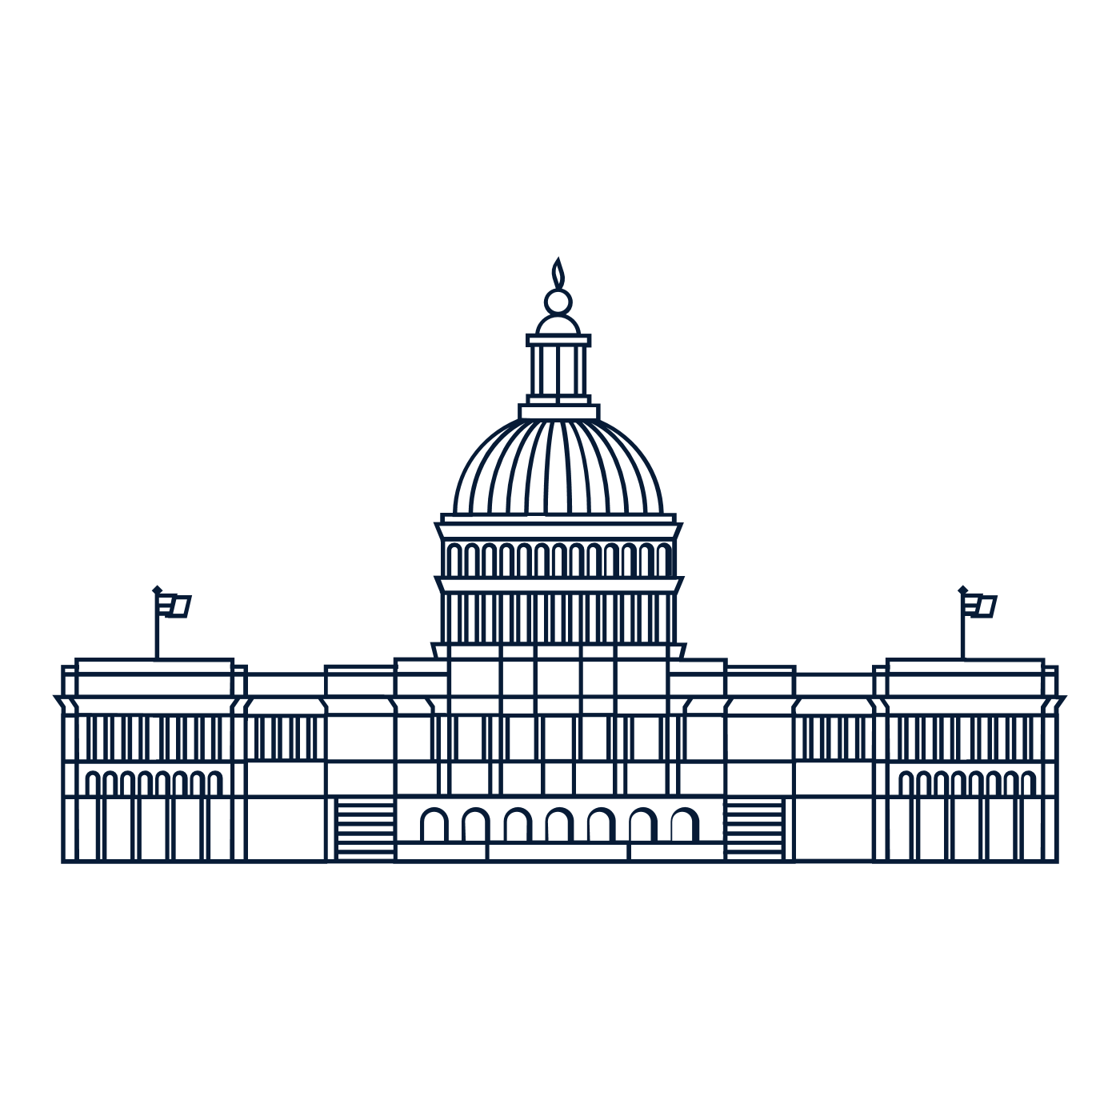

Scholar Exchange: Article I - How Congress Works
Class Outline and Worksheet

Overview

Part I: How Does Congress Work
Part II: Founding Story – The Constitutional Convention
Part III: Congress’s Powers Throughout History
Part IV: Hypothetical – A National Mask Mandate

Questions to Consider

- What role does Congress have in the national government?
- What powers does the Constitution grant to Congress? And what are some of the limits on congressional power?
- How did the Framers come up with Congress, and what were some of the debates at the Constitutional Convention?
- Has the original vision for what Congress should be changed over time?
- What are some of the Supreme Court’s key decisions on congressional power? And what are some of the topics of ongoing constitutional debate?
Big Idea

The power to make laws in our country falls in the hands of the Legislative Branch. The branch is outlined in Article I of the Constitution. The Legislative Branch is divided into two houses of Congress. The House of Representatives is made up of representatives proportionate to their state’s population while each state maintains equal representation in the Senate. With Congress, the Founding generation set up a national legislature to make the nation’s laws. They looked to create a new national legislature with more authority—and ability to act—than the one that came before it, but also one of limited powers and slow deliberation required to make change. Through five different periods in United States history, the powers and roles of Congress have shifted to create the Legislative Branch as we know it today.

NOTES:

I. The Original Powers (and Limits) of Congress
Review the text from Article I of the Constitution. What was the Founding generation’s vision for Congress, its powers, its limits, and its duties? How would the Legislative Branch interact with the Executive and Judicial Branches?

II. How Does It Work? The Congressional Process
How does a bill pass through the United States Congress? How does the executive branch play a role in this process?

III. How Should it work? The Convention’s Longest Debate
At the Constitutional Convention, what were some of the key debates over Congress and its powers? Describe TWO key debates and TWO important delegates from these arguments in your answer.

IV. “Stronger, But Not TOO Strong!”: Searching for a balanced System
What was the Founding generation’s vision for Congress, its powers, and its duties? How would the Legislative Branch interact with the Executive and Judicial Branches?

V. The Evolution of Congress
How has the role of Congress in our constitutional system changed over time? Describe at least TWO eras in American history in which the powers of Congress were expanded or limited.

VI. Congress and the Supreme Court
What were some of the Supreme Court’s key decisions that influenced congressional power? Name and describe TWO landmark case rulings.

VII. Examining Congress through the Constitution Today
Does Congress have the power to pass a law requiring everyone to wear a mask during the COVID-19 pandemic? Include TWO key clauses from the Constitution to support your answer.

